Assignment week-4.3(wed)

Name:B.Pranitha

HTNO:2403A51351

**Task Description#1**

* Zero-shot: Prompt AI to write a function that checks whether a given year is a leap year.

Prompt



Code

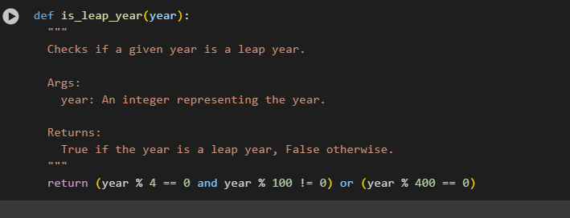

**Expected Output#1**

* AI-generated function with no examples provided

Because the zero shot means the code should not give any examples

**Task Description#2**

* One-shot: Give one input-output example to guide AI in writing a function that converts centimeters to inches.

Prompt:



Code:

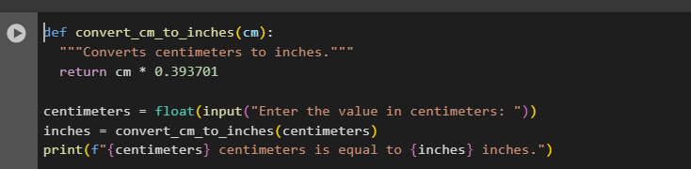 **Expected Output#2**

* Function with correct conversion logic

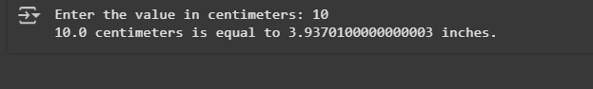

**Task Description#3**

* Few-shot: Provide 2–3 examples to generate a function that formats full names as “Last, First”.

Prompt :



Code

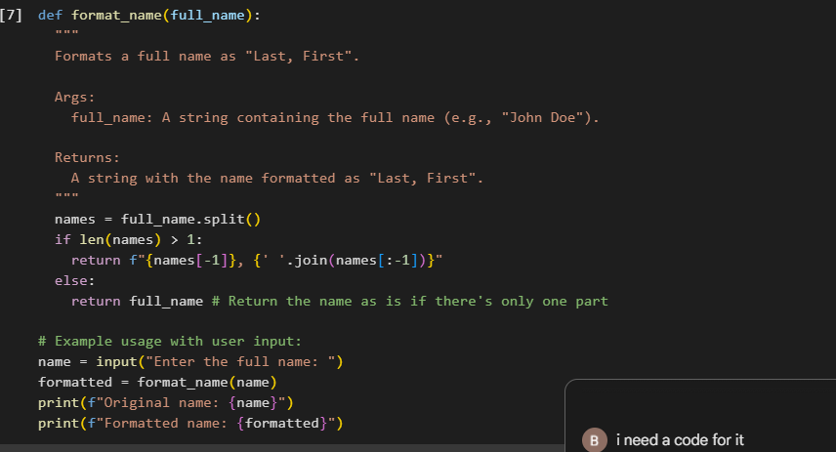

**Expected Output#3**

Well-structured function respecting the examples

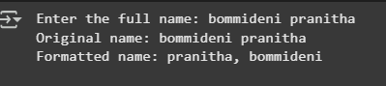 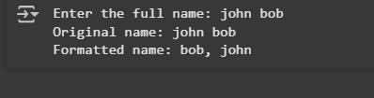

**Task Description#4**

* Compare zero-shot and few-shot prompts for writing a function that counts the number of vowels in a string.

**Prompt**

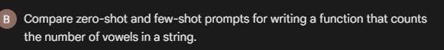

**Code:**

* 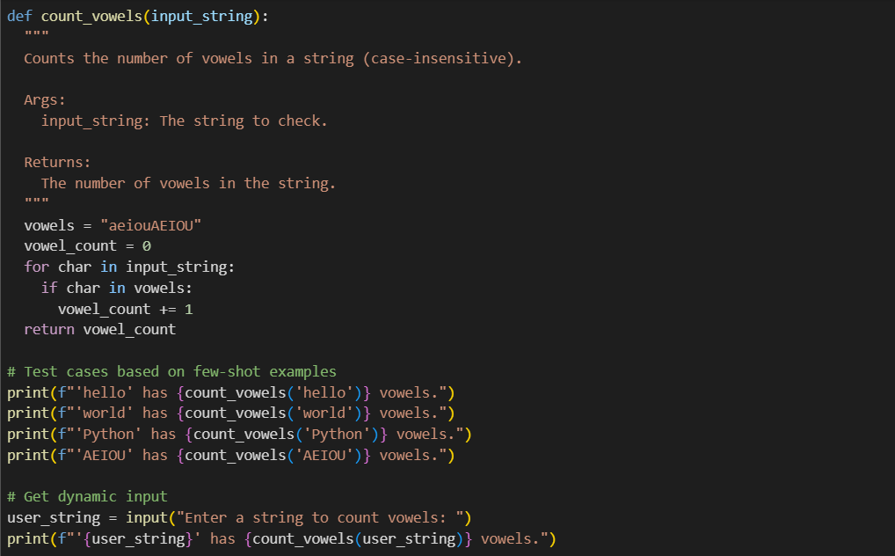

**Expected Output#4**

* Functional output and comparative reflection

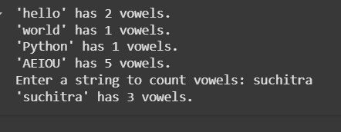

**Task Description#5**

* Use few-shot prompting to generate a function that reads a .txt file and returns the number of lines.

**Prompt:**

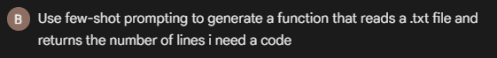

**Code:**

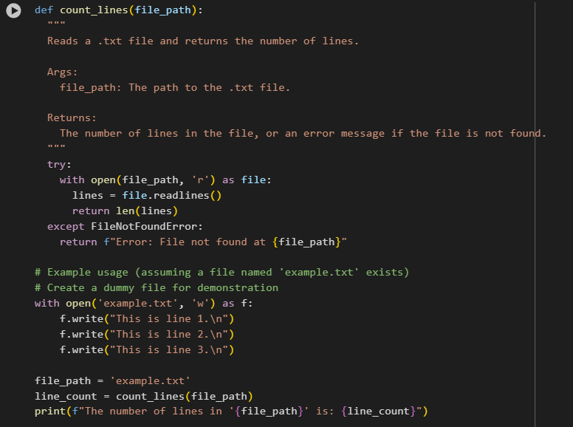

**Output:**

**Expected Output#5**

Working file-processing function with AI-guided logic

